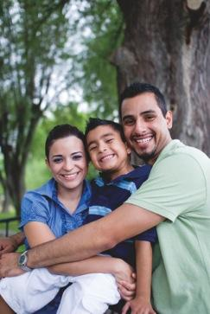

Parish Name Here

**2023 STEWARDSHIP REPORT**

**Note From the Pastor**

September XX, 2023

Dear Friends and Families of our Parish,

Ut harchit et ea si ulpa ipsa con nisquid que pres sitate rese opta deligni temporibus, accus nonestis imusame porerovid qui intioriam untur moluptaque nempor molum nobit aspiendi ut autatint.

Con re il idunt quo torecto estia nonsed quisquae dolore, culparum res vere dolo

fugit ium quiaeserum dest odis et ut ut omnis et, quid ea suscipsant volor a debit et ulla sitaturio. Et ut alitis sequia si ut reni omnimilita autentios que andipsant omnimil et moditat iuntiumet mo molupta tiuntora pla simaio et erchillique si con cor alique esed es mo ditae nos velis imus nim ex earuptatur?

Perum unt dolupta taerchi llatet eum eatem. Nam volorem verovit fugitatio. Venda sum iur? Mendell aborum eos dolores modigni tinctorate ped eos sapedit odi velis re is doles es autemped quidi ipisitam faccumquost occae porum rehentis magnam et quam erum et alicipsunt.

Antiatuscium sapitasit doluptatet, optat.

Father John Smith  
Pastor





PRAYER



**Prayer & Participation**

Show your numbers! As Dizzy Dean once said, "It ain't braggin' if you can back it up.” Use this area to list your parish’s facts and figures, from the number of families, to baptisms, to canned goods donated. See the sample list, below.

• 1,500 families in our parish

• 4,284 registered parishioners

• 52 new families this year!

• 563 backpacks prepared for

St Patrick’s Center   
 Back-to- School programs

• 92 volunteer Eucharistic ministers

• 93 funerals

• 47 weddings

• 51 infant baptisms

• 16 RCIA participants

• 72,000 canned goods donated

to our food pantry

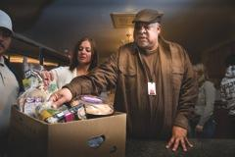



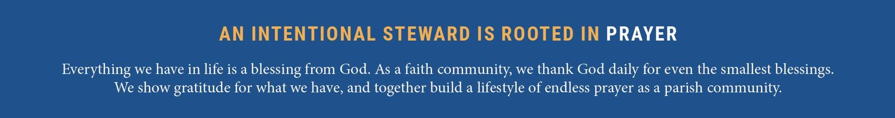

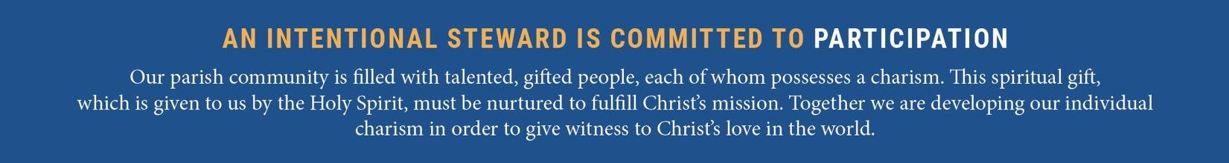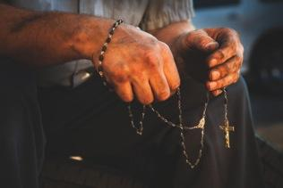

PARTICIPATION

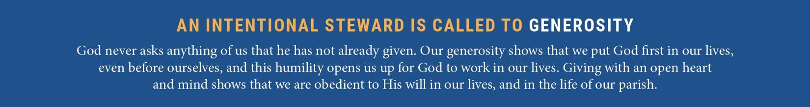

GENEROSITY